.
SUBJECT: CULTURAL AND CREATIVE ART
ALPHA TERM SCHEME OF WORK
CLASS: JSS1

WEEK TOPIC
1. | DEFINITION OF CULTURAL AND CREATIVE ARTS
2. | INTRODUCTION TO ART, TYPES AND BRANCHES
3. | THEORY OF MUSIC
4. | DEFINITION OF DRAMA AND THEATRE
5. | TEAM WORK AND SENSE OF BELONGING
6. | DANCE
7. | PRINCIPLES AND ELEMENTS OF ART
8. | RUDIMENTS AND THEORY OF MUSIC
9. | FORMS/TYPES OF DRAMA
10. | MOLD WITH PAPER MACHE
11 | FUNDAMENTAL / ELEMENTS OF MUSIC
12-13 | REVISION AND EXAMINATION

WEEK 1
SUBJECT: CULTURAL AND CREATIVE ARTS
TOPIC: INTRODUCTION TO CULTURAL & CREATIVE ART
CLASS: JSS1

CONTENTS:
The term “Creative and Cultural Sector” is referred to often in the research and practice of creative place making. But what does it mean? Read the following guide to learn about the creative and cultural sector and statistical frameworks for measuring its reach.

Cultural and creative art is a new concept that merges three areas of disciplines {Visual arts, Music and Drama or Theatre} as one subject.
Cultural and Creative Art is a subject tat studies human being in his beautiful environment together with his culture, how he communicates within the culture, the degree of his appreciation for the works of art and preservation of his culture.

The creative and cultural sector boasts strong interest from communities and governments with potential for significant growth as a sustainable approach to economic development. The workers employed in this sector are creators, participants and consumers of culture characterized as independent artists, self-employed entrepreneurs and micro-businesses.

These three areas reflect the cultural ways, societal interests and beliefs of the people. Art, music and drama cannot be separated from our ways of life which is our culture. Art materials are what makes our culture .therefore creative art and culture cannot be separated.

HISTORY OF ART
The history of art is the history of any activity or product made by humans in a visual form for aesthetical or communicative purposes, expressing ideas, emotions or, in general, a worldview. Over time visual art has been classified in diverse ways, from the medieval distinction between liberal arts and mechanical arts, to the modern distinction between fine arts and applied arts, or to the many contemporary definitions, which define art as a manifestation of human creativity. The subsequent expansion of the list of principal arts in the 20th century reached to nine:

MUSIC
Music has been called the language of emotions. This is not an unreasonable metaphor, for music, like language, aims to communicate meaning.
Music can be defined as the arrangement of both natural and artificial sounds which is pleasant to the ears.
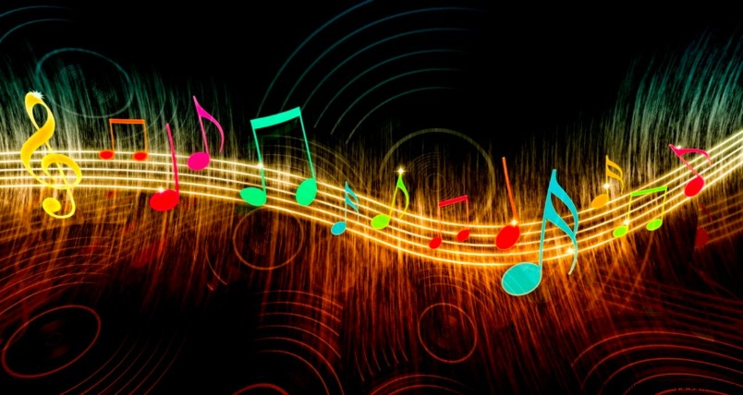

DRAMA
Drama is an art form that tells a story through the speeches and actions of the characters in the story. In drama actors and actresses impersonate characters before an audience in a theatre.
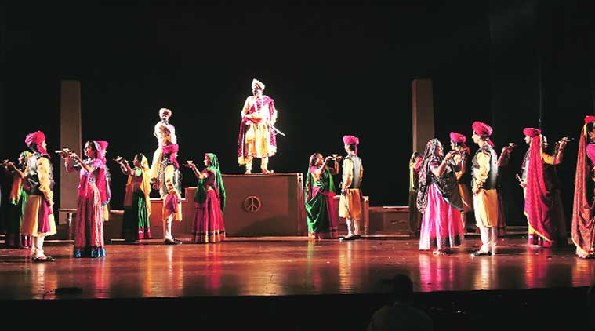

CULTURAL AND CREATIVE ARTS
The term “Creative and Cultural Sector” is referred to often in the research and practice of creative place making. Cultural and creative art is new concept that combine art three different art i.e V and creativity, Performing
Considered globally as a driver of the knowledge economy, the creative and cultural sector is increasingly understood to play a crucial role in economic life, attracting talent and investment, building international reputation and catalyzing innovation across all sectors of the economy. The sector employs approximately 1.1 million people in Canada with a broad impact that transforms communities, enriches the lives of individuals and regenerates neighborhoods.

The creative and cultural sector boasts strong interest from communities and governments with potential for significant growth as a sustainable approach to economic development. The workers employed in this sector are creators, participants and consumers of culture characterized as independent artists, self-employed entrepreneurs and micro-businesses.

Defining the Creative and Cultural Sector
As a broad, complex and evolving mix of industries that range from the performing and visual arts to magazine publishing, digital media and design, there is no commonly recognized definition of the breadth (i.e. industry and occupational composition) and depth (i.e. extent of the value chain) of the sector internationally – however, there is emerging consensus on the key industries that constitute its nucleus.

Art scape uses a typology created by The Work Foundation to define the creative and cultural sector. This encompasses three key components: core creative fields, cultural industries and creative services.

Core Creative Fields: focus on the production of “originals” (e.g., visual arts, artisan crafts, designer-makers) and “experiences” (e.g. live theatre, dance, and music as well as heritage). Their commercial outputs possess a high degree of expressive value and invoke copyright protection.

Cultural Industries: focus on creative content-producing industries, whether private or public, which exploit intellectual property (IP) through mass production (e.g., film and television production, broadcasting, record companies, book and magazine publishers, computer games and leisure software). Their activities involve mass reproduction of expressive outputs based on copyright.

Creative Services: are based around providing creative services to clients, earning revenue through fee-for-service and providing IP that has a high degree of both expressive and functional value (e.g., design consultancies, advertising agencies, architecture practices, digital media firms). The use of expressive value is essential to the performance of these sectors.

WEEK 2
TOPIC: INTRODUCTION TO ART
CLASS: JSS1

CONTENTS: Art can be defined as a very wide human activities involving some skills. It is imaginative, creative and aesthetic in nature. One uncontroversial thing about art is that it affects almost every aspect of man’s life.

SOME DEFINATIONS OF ART
- Art is a means of self-expression of inner feelings or ideas about things, people and the environment
- Art is the act of making skillful use of materials to produce things for human use and pleasure.
- Art is a universal language of expression.
Art is the skill of doing something, which is not taught by nature.

THE ORIGIN OF ART
The word “Art” originated from a latin word “ARTI” which means “to do well”. Art activities could be traced back to the early man, who wrote and drew on cave walls, rock surfaces, wood and hides. Although most of these materials are aged, utility and beauty or aesthetics, weathered and perished.
The various techniques used in representing objects on such surfaces includes scratching, engraving, incised drawing or graffiti and painting. Such painting were carried out with earth colours –red, yellow, black and white of chalk mixed with animal fat to form a kind of oil paint.

BRANCHES OF ART

Art, a name given to all skillful activities is broadly divided into too namely VISUAL ART and NON-VISUAL ART.

VISUAL ART: Are those aspect of art whose products are visible. i.e. what we can see. It requires the use of materials that we can see physically or touched.

Visual Art can be divided into two namely: Fine Art and Applied Art/Industrial Art.
They are mainly for self satisfaction.

The branches of Fine art are: Drawing, Painting, Sculpture, and Architecture.

While the branches of Applied art are ; Graphics, Textile, Ceramics, Photography etc.

NON-VISUAL ART: These are the aspects of art whose product can not be seen with our naked eye. The products are mainly for entertainment and recreation.

Non-visual Art - can also be divided into two namely: Performing Art and Literary Art.
Performing art includes music, Drama, Dance,

While Literary Art involves all form of writing Literature, Poetry, Folklore and Jonalism.





ART

VISUAL ART NON-VISUAL ART

FINE ART APPLIED/ PERFORMING LITERARY
INDUSTRIAL ART ART ART

DRAWING GRAPHICS DRAMA LITERATURE
PAINTING TEXTILE MUSIC POETRY
SCULPTURE CERAMICS DANCE WRITING
ARCHITECTURE PHOTOGRAPHY FOLK LOVE
INTERIOR DESIGN JOURNALISM
FURNITURE “ “
INDUSTRIAL “ “

IMPORTANCE OF ART

Art serve many functions and has many values to the society. All the branches of art are important because they all satisfy and affect the life of human beings in diverse ways some of which are:

1. Art serves as the means of expressing our emotions

2. Art works serves as decorative means

3. Art works are used to retain and promotes our fashion culture

4. Art works serves the means of protection

5. Art works serves as a storage means

6. Art works encourages the people spiritual growth

7. Art works creates room for relaxation, recreation, and increases in ones joy

8. Art helps in keeping records and historical facts about our ancestors

9. Art serves as aid to easy transportation of goods

10. Art is used as a means of effective communication within individual, local and international communities

11. Art serves as a source of income for individual and society.

WEEK 3
TOPIC: THEORY OF MUSICS
CLASS: JSS1
CONTENT
Music is found in every known culture, past and present, varying widely between times and places. Since all people of the world, including the most isolated tribal groups, have a form of music, it may be concluded that music is likely to have been present in the ancestral population prior to the dispersal of humans around the world. Consequently, music may have been in existence for at least 55,000 years and the first music may have been invented in Africa and then evolved to become a fundamental constituent of human life.
History of music
Early music is music of the European classical tradition from after the fall of the Roman Empire, in 476 AD, until the end of the Baroque era in the middle of the 18th century. Music within this enormous span of time was extremely diverse, encompassing multiple cultural traditions within a wide geographic area; many of the cultural groups out of which medieval Europe developed already had musical traditions, about which little is known. What unified these cultures in the Middle Ages was the Roman Catholic Church, and its music served as the focal point for musical development for the first thousand years of this period.

A culture's music is influenced by all other aspects of that culture, including social and economic organization and experience, climate, and access to technology. The emotions and ideas that music expresses, the situations in which music is played and listened to, and the attitudes toward music players and composers all vary between regions and periods. "Music history" is the distinct subfield of musicology and history which studies music (particularly Western art music) from a chronological perspective
While musical life was undoubtedly rich in the early Medieval era, as attested by artistic depictions of instruments, writings about music, and other records, the only repertory of music which has survived from before 800 to the present day is the plainsong liturgical music of the Roman Catholic Church, the largest part of which is called Gregorian chant. Pope Gregory I, who gave his name to the musical repertory and may himself have been a composer, is usually claimed to be the originator of the musical portion of the liturgy in its present form, though the sources giving details on his contribution date from more than a hundred years after his death. Many scholars believe that his reputation has been exaggerated by legend. Most of the chant repertory was composed anonymously in the centuries between the time of Gregory and Charlemagne.

WEEK 4
TOPIC: DEFINITION OF DRAMA AND THEATER
CLASS: JSS1

CONTENT
Drama and theatre are forms of art that have been used interchangeably over time or express the activities around playwright and Creator of theatrical events.
Drama can be defined as an act form that tells a story through the speeches and actions of the characters in the story.
Drama can also be said to be synonymous with play. A play is a work of story telling in which characters are represented by actors and actress.
Drama is the specific mode of narrative, typically fictional, represented in performance.

[1] The term comes from the Greek word , drama, meaning action, to do or to act. The enactment of drama in theatre, performed by actors on a stage before an audience, presupposes collaborative modes of production and a collective form of reception. The structure of dramatic texts, unlike other forms of literature, is directly influenced by this collaborative production and collective reception.

[2] The early modern tragedy Hamlet (1601) by Shakespeare and the classical Athenian tragedy Oedipus the King (c. 429 BC) by Sophocles are among the masterpieces of the art of drama.

[3] A modern example is Long Day's Journey into Night (1956) by Eugene O’Neill.

[4] The two masks associated with drama represent the traditional generic division between comedy and tragedy. They are symbols of the ancient Greek Muses, Thaliana and Melpomene, the Muse of comedy represented by the laughing face, and the Muse of tragedy represented by the weeping face, respectively. Considered as a genre of poetry in general, the dramatic mode has been contrasted with the epic and the lyrical modes ever since Aristotle's Poetics (c. 335 BC)—the earliest work of dramatic theory.

PEOPLE INVOLVE IN DRAMA

There are different categories of people involve in drama/theatre. These includes Actors, Actress, Audience, Stage Manager, Producer, Stage Designer, Costumier, Prop Designer, Lighting Designer e.t.c.

Theatre is a collaborative form of fine art that uses live performers, typically actors, to present the experience of a real or imagined event before a live audience in a specific place, often a stage.
The performers may communicate this experience to the audience through combinations of gesture, speech, song, music, and dance. Elements of art, such as painted scenery and stagecraft such as lighting are used to enhance the physicality, presence and immediacy of the experience. The specific place of the performance is also named by the word "theatre" as derived from the Ancient Greek meaning ("to see", "to watch", "to observe").
Modern Western theatre comes, in large measure, from ancient Greek drama, from which it borrows technical terminology, classification into genres, and many of its themes, stock characters, and plot elements. Theatre artist Patrice defines theatricality, theatrical language, stage writing, and the specificity of theatre as synonymous expressions that differentiate theatre from the other performing arts, literature, and the arts in general.

WESTERN OPERA
Western opera is a dramatic art form, which arose during the Renaissance in an attempt to revive the classical Greek drama tradition in which both music and theatre were combined. Being strongly intertwined with western classical music, the opera has undergone enormous changes in the past four centuries and it is an important form of theatre until this day. Noteworthy is the major influence of the German 19th-century composer Richard Wagner on the opera tradition. In his view, there was no proper balance between music and theatre in the operas of his time, because the music seemed to be more important than the dramatic aspects in these works. To restore the connection with the traditional Greek drama, he entirely renewed the operatic format, and to emphasize the equal importance of music and drama in these new works, he called them "music dramas".
CHINESE OPERA
Chinese opera has seen a more conservative development over a somewhat longer period of time.

Pantomime
These stories follow in the tradition of fables and folk tales. Usually there is a lesson learned, and with some help from the audience, the hero/heroine saves the day. This kind of play uses stock characters seen in masque and again commedia dell'arte, these characters include the villain (doctors), the clown/servant,, the lovers etc.
These plays usually have an emphasis on moral dilemmas, and good always triumphs over evil, this kind of play is also very entertaining making it a very effective way of reaching many people.

MIME
Mime is a theatrical medium where the action of a story is told through the movement of the body, without the use of speech. Performance of mime occurred in Ancient Greece, and the word is taken from a single masked dancer called Pantomimes, although their performances were not necessarily silent. In Medieval Europe early forms of mime, such as mummer plays and later dumb shows, evolved. In the early nineteenth century Paris, Jean-Gaspard Deburau solidified the many attributes that we have come to know in modern times, including the silent figure in whiteface.
Jacques Copeau, strongly influenced by Commedia and Japanese Noh theatre, used masks in the training of his actors. Decroux, a pupil of his, was highly influenced by this and started exploring and developing the possibilities of mime and refined corporeal mime into a highly sculptural form, taking it outside of the realms of naturalism.
Jacques Lecoq contributed significantly to the development of mime and physical theatre with his training methods.

CREATIVE DRAMA
Creative drama includes dramatic activities and games used primarily in educational settings with children. Its roots in the United States began in the early 1900s.Winifred Ward is considered to be the founder of creative drama in education, establishing the first academic use of drama in Evanston, Illinois

WEEK 5
TOPIC: TEAM WORK AND SENSE OF BELONGING
CLASS: JSS1

CONTENT: The nature of teams may be changing, but the underlying nature and benefits of teams are not. Teams are becoming more numerous and complex, with one person often being a member of a number of teams in an organization. Recent discussions have highlighted.
These team structures are in addition to the formal organizational unit structure where team members reside. They are expected to use teamwork to complete the functional aspects of their positions along with their colleagues in the same organizational unit.
Team Norms
Some norms are more-or-less universal among working groups, or within a particular organization. But there may also be norms specific to the team, so as a newcomer, you’ll want to learn them quickly. This is one of the purposes of training—whether it’s Boot Camp in the military, corporate training, or multi-day employee orientation when you start a new job.
- In one medium sized organization, formal management responsibilities being assigned to teams of people from different parts of the organization. Instead of having formal positions for specific functions (human resources, health and safety, etc), a committee structure has been created and successfully implemented. This helps ensure that the responsibility and accountability for these important functions is shared between a number of people.
- In one technology based company, product and system implementations for different clients require different parts of the organization to provide services. Consequently, the project team can be very different for each client, depending on the expertise required. Team members may be based locally, in Australia or other parts of the world.

HOW DO YOU ACHIEVE GOOD TEAMWORK?
Good teamwork starts with a shared understanding of its importance. Many organizations recruit people with an aptitude for and leaning towards teamwork. Their induction process emphasizes it. The way teams work demonstrates it. Although team members have clear and designated responsibilities, they help others when required. Good teamwork behavior is recognized and rewarded. Teamwork is built into the organization culture - it is a part of 'the way we do things around here'.

SENSE OF BELONGING
In another services company, staff find themselves working in multiple teams at the same time. At any given part of the year, the number of projects can range from two to six, depending on the current client assignments
But suppose you create or join a brand new team at its inception? At some point, you’ll have to get together and establish your new team’s norms. This can happen on the fly with on-the-job training; the norms may even be unwritten, understood implicitly by all. But I find it more logical to establish a formal set of team norms as soon as possible. Ideally, your leader will sit you all down at a meeting before you get too far; you can suggest it if not. Shoot for these foundations:
STEPS IN ACHIVING SENSE OF BELONGING.
- Solid communication. Communicate concisely and cleanly, with acknowledgement of each communication. If you can’t fulfill a request, give an estimate for completion. a minimum. Don’t “reply all” if you aren’t adding to conversation with information that does indeed apply to all.
- Mutual respect. Establish this from the start. Everyone has a place on the team for a reason and has their own specialized knowledge. No one is more or less important than anyone else on the team.
- Meeting guidelines. Begin and end the meeting on time. Work from an agenda distributed several days before. Establish rules of order. Use a facilitator. Take minutes. Don’t hog the floor. Don’t talk just to hear yourself talk. Avoid side conversations.
- Decision-making. What decisions will the leader make? Which ones need team input? Will we make major decisions by consensus or majority? Will the team give input and the leader makes the final decision?
- Self-review. Meet occasionally to review your collective performance and productivity. Review processes to determine how to save time. Review relevant metrics and indicators. Always seek ways to save time individually and collectively.
- Conflict resolution. Determine ways to directly resolve conflict between individuals, varying according to the level of conflict. Remember: you may require some friction and debate for effective decision-making, so don’t automatically reach for conflict resolution procedures when things get a little heated.
Celebration. Having a small party or presenting awards after a successful task or project helps establish team solidarity. When it’s not excessive, socializing is necessary for bonding and relationship building.

WEEK 6
TOPIC: TOPIC: DANCE
CLASS: JSS1

CONTENT

Dance is any body movement home or space for express human emotion in reaction to musical performance anywhere. It is an organized movement of the body to musical rhythm. It could be for fun to narrate a story, to inform or entertain.

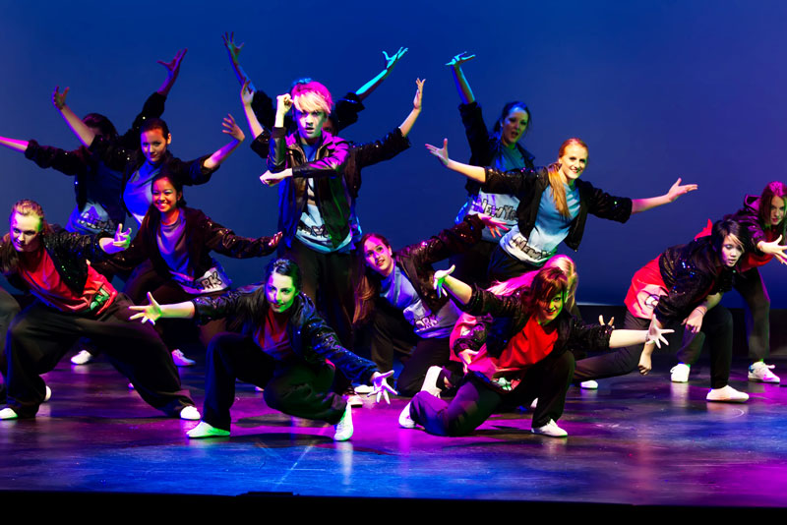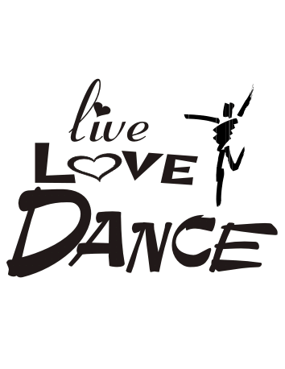

STRUCTURE OF DANCE
Dance has three basic structures, they are:
- The beginning: This includes entry warm up and first impression.
- The middle: This includes dancing proper and the climax.
- The end: This includes rounding off last impression and exists.

ESSENTIAL OF A DANCE

- Body awareness: The body is the most important instrument for dance to make series of gesture and miming.

- Awareness of weight: The weight of a dancer in reaction to his presentation matters a lot weight is the quality in movement. It is characterization by firmness or lightness. Lightness is referred to as graceful and gentle movement while heavy weights are low.

- Awareness of apace: Space is necessary for comfortable dance. It can be in form of village scow are, foot ball fields, market square e.t.c. types of space available for dance are:

- Personal space: The immediate space in mounding a dancer.

- Fore space: Is the wider general space.

- Awareness of time: This refers to the timing of movements in terms of spend which is usually described as sudden swift, smart and sharp movement in respect of time is the slow line ring one.

WEEK 7
TOPIC: PRINCIPLES AND ELEMENTS OF ARTS

CLASS: JSS1

CONTENT
The Principles of design can be thought of as what we do to the elements of design. How we apply the Principles of design determines how successful we are in creating a work of art.

THE PRINCIPLES OF DESIGN
BALANCE
Balance in design is similar to balance in physics
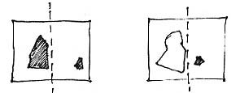
A large shape close to the center can be balanced
by a small shape close to the edge.
DOMINANCE
Dominance gives a painting interest, counteracting confusion and monotony. Dominance can be applied to one or more of the elements to give emphasis
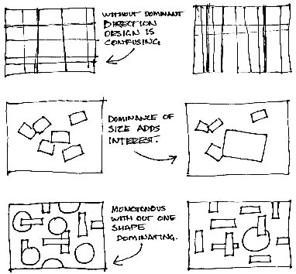
REPETITION
Repetition with variation is interesting, without variation repetition can become monotonous.
CONTRAST
Contrast is the juxtaposition of opposing elements e.g. Opposite colours on the colour wheel - red / green, blue / orange etc. Contrast in tone or value - light / dark. Contrast in direction - horizontal / vertical.
HARMONY
Harmony in painting is the visually satisfying effect of combining similar, related elements.
UNITY
Relating the design elements to the the idea being expressed in a painting reinforces the principal of unity.
GRADATION
Gradation can add interest and movement to a shape. A gradation from dark to light will cause the eye to move along a shape.

THE ELEMENTS OF DESIGN
The elements and principles of design are the building blocks used to create a work of art. The elements of design can be thought of as the things that make up a painting, drawing, design etc. Good or bad - all paintings will contain most of if not all, the seven elements of design.
LINE
Line can be considered in two ways. The linear marks made with a pen or brush or the edge created when two shapes meet.
SHAPE
A shape is a self contained defined area of geometric or organic form. A positive shape in a painting automatically creates a negative shape.
TEXTURE
Texture is the surface quality of a shape - rough, smooth, soft hard glossy

WEEK 8
TOPIC: RUDIMENTS AND THEORY OF MUSIC IC
CLASS: JSS1

Rudiments of Music
The Staff - music is written on a staff that has five lines and four spaces.
The letter names of the lines are E, G, B, D, F. It's easily remembered by the sentence:
Every Good Boy Does Fine
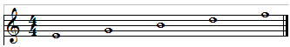
E G B D F

The letter names of the spaces from the bottom up spell FACE.
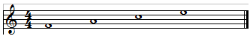
F A C E
It's very important to remember the names of the lines and spaces of the staff.

Types of Notes - the type of note indicates the duration or how long you let the note ring.
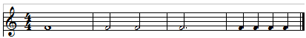
1 2 3 4
1. Whole Note - 4 beats, the whole note is a hollow head and doesn't have a stem.
2. Half Note - 2 beats, the half note has a hollow head and a stem. There are two half notes in the second measure, each one gets 2 beats.
3. Dotted Half Note - 3 beats, the dot placed after any note adds to that note half of its original value.
4. Quarter Note - 1 beat, the quarter note has a solid head and a stem. There are four quarter notes in measure 4, each one gets a beat.
The Rest - a sign indicating to stop a note, for every type of note there is an equivalent rest.
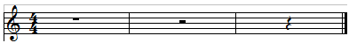
1 2 3
1. Whole Rest - 4 beats
2. Half Rest - 2 beats
3. Quarter Rest - 1 beat
Time Signatures - indicate how the measure will be divided into beats, the top number is how many beats are in the measure and the bottom number is what kind of note gets a beat. The following example shows the most basic time signatures.
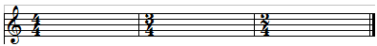
1 2 3
1. 4/4 time - divides measure into 4 beats.
2. 3/4 time - divides measure into 3 beats.
3. 2/4 time - divides measure into 2 beats.
How to Read Music This is a great place to start if you're a beginner.
Basic Technique - The following lessons are the most important for beginners or those who have been playing and are looking for a way to improve their technique and are a prerequisite before moving on to the Complete Basic Rhythm Course or any other advanced lessons.

WEEK 9
TOPIC: FORMS/TYPES OF DRAMA
CLASS: JSS1

CATEGORIES OF DRAMA
Drama was broadly categorized into three different forms, viz. opera, pantomime, and creative drama. We explain them in the following points.
Opera: this form was accepted warmly during the Renaissance period due to its versatility. Theater and music were in perfect harmony, and the actors displayed exceptional acting and singing skills.
Pantomimes: These were composed keeping the theme of folk tales as the primary element, and symbolism occupied a prominent position. It was organized in the form of masques, where characters wore elaborate costumes and makeup.
Creative drama: It is the modern version of drama, which was popularized mostly by youngsters, possessing innate acting skills. Stage shows and theaters were organized in schools and colleges, which provided a platform for students to exhibit their talent.
No matter what the form, every drama contain some basic elements. The components of drama are: theme, plot, audio-visual effects, and music. All these elements must be synchronized perfectly for creating a masterpiece.
DIFFERENT TYPES OF DRAMA
A comedy makes us laugh when the play is well-composed with the humorous elements. The story is usually based on real-life characters, funny experiences in life, or any type of fun-provoking situation. A comical drama can also be sarcastic and raunchy. It is usually light in tone and has happy endings. Composing a comical drama requires high level of intellect and perceptive faculties, because provoking laughter is not as easy as it may seem.
According to the definition given by Britannica, it is a comic dramatic piece that uses highly improbable situations, stereotyped characters, extravagant exaggeration, and violent horseplay. Farce, although a sub-category of comedy, is intellectually inferior to comedy because the plots and the characters are substantially crude, ambiguous, and unimaginative.
It is one of the oldest forms of drama. It exposes the plight and suffering of humans to the audience. The perfect example of a tragic drama is Shakespeare's Hamlet. The theme of a tragedy usually rotates around the ruins of a dynasty, downfall of man, emotional betrayals, moral setback, personal loss, death, and denials. A tragedy when composed and enacted well can touch you deeply. These rarely have happy endings.
Melodrama is exaggeration of emotions. It's marked by a surge of emotions, which is a technique to make the character and the plot more appealing to the audience. A melodrama can sometimes fail to derive applause, because excessive display of emotions can become monotonous. On the contrary, a superbly executed melodramatic plot can absorb you completely. They usually depict the good and evil aspects of the characters involved.
It is a complete fictional work where characters virtually display supernatural skills. It is more appealing to children as fairies, angels, superheroes, etc., are embedded in the plot. Use of magic, pseudo science, horror, and spooky themes through various kinds of technical devices create a perfect world of fantasy. The modern version of drama incorporates a great deal of special effects.
Music, melody, and dance play a significant role in a musical drama. Here, the story is conveyed through music and dance along with dialogs and acting. The music should be in sync with the actions, and the performer often uses dance as a means of self-expression. The stage may be equipped with an orchestra, well-rehearsed with the plot and the use of music. Musical drama became popular as opera, which is still considered to be intensely sensuous.

WEEK 10
TOPIC: TOPIC: MOLD WITH PAPER MACHE

CLASS: JSS1

Paper mache can be defined as a wet paper, pounded and mixed with starch, prepared in form of clay to be used for modeling.

Papier-mâché "chewed paper", is a composite material consisting of paper pieces or pulp, sometimes reinforced with textiles, bound with an adhesive, such as glue, starch, or wallpaper paste. Preparation methods.
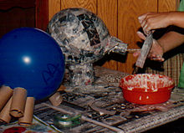
Papier-mâché with the strips method for the creation of a pig.
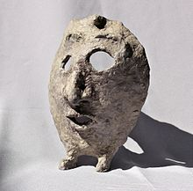
Papier-mâché mask created with the pulp method
Two main methods are used to prepare papier-mâché; one makes use of paper strips glued together with adhesive, and the other method uses paper pulp obtained by soaking or boiling paper to which glue is then added.
With the first method, a form for support is needed on which to glue the paper strips. With the second method, it is possible to shape the pulp directly inside the desired form. In both methods, reinforcements with wire, chicken wire, lightweight shapes, balloons or textiles may be needed.
The traditional method of making papier-mâché adhesive is to use a mixture of water and flour or other starch, mixed to the consistency of heavy cream. Other adhesives can be used if thinned to a similar texture, such as polyvinyl acetate-based glues (wood glue or, in the United States. Adding oil of cloves or other additives such as salt to the mixture reduces the chances of the product developing mold.
For the paper strips method, the paper is cut or torn into strips, and soaked in the paste until saturated. The saturated pieces are then placed onto the surface and allowed to dry slowly. The strips may be placed on an armature, or skeleton, often of wire mesh over a structural frame, or they can be placed on an object to create a cast. Oil or grease can be used as a release agent if needed. Once dried, the resulting material can be cut, sanded and/or painted, and waterproofed by painting with a suitable water-repelling paint.
Before painting any product of papier-mâché, the glue must be fully dried, otherwise mold will form and the product will rot from the inside out.

EUROPE

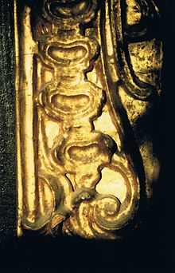
Detail of gilt papier-mâché as applied to an English picture frame
Starting around 1725 in Europe, gilded papier-mâché began to appear as a low-cost alternative to similarly treated plaster or carved wood in architecture. Henry Clay of Birmingham, England, patented a process for treating laminated sheets of paper with linseed oil to produce waterproof panels in 1772. These sheets were used for building coach door panels, amongst other structural uses. Theodore Jennens patented a process in 1847 for steaming and pressing these laminated sheets into various shapes, which were then used to manufacture trays, chair backs, and structural panels, usually laid over a wood or metal armature for strength. The papier-mâché was smoothed and lacquered, or finished with a pearl shell finish. The industry lasted through the 19th century. Russia had a thriving industry in ornamental papier-mâché. A large assortment of painted Russian papier-mâché items appear in a Tiffany & Co. catalog from 1893. Martin Travers the English ecclesiastical designer made much use of papier-mâché for his church furnishings in the 1930s.
Papier-mâché has been used for doll heads starting as early as 1540, molded in two parts from a mixture of paper pulp, clay, and plaster, and then glued together, with the head then smoothed, painted and varnished.

Paper boats
One common item made in the 19th century in America was the paper canoe, most famously made by Waters & Sons of Troy, New York. The invention of the continuous sheet paper machine allows paper sheets to be made of any length, and this made an ideal material for building a seamless boat hull. The paper of the time was significantly stretcher than modern paper, especially when damp, and this was used to good effect in the manufacture of paper boats. A layer of thick, dampened paper was placed over a hull mold and tacked down at the edges. A layer of glue was added, allowed to dry, and sanded down. Additional layers of paper and glue could be added to achieve the desired thickness, and cloth could be added as well to provide additional strength and stiffness. The final product was trimmed, reinforced with wooden strips at the keel and gunwales to provide stiffness, and waterproofed. Paper racing shells were highly competitive during the late 19th century. Few examples of paper boats survived. One of the best known paper boats was the canoe, the "Maria Theresa," used by Nathaniel Holmes Bishop to travel from New York to Florida in 1874–75. An account of his travels was published in the book "Voyage of the Paper Canoe."

PAPER MASKS
Creating papier-mâché masks is common among elementary school children and craft lovers. Either one's own face or a balloon can be used as a mold. This is common during Halloween time as a facial mask complements the costume.

HOW TO MOLD WITH PAPER MACHE
Step 1 Make paste Make papier-mâché paste by mixing equal parts flour and water in a bowl, stirring the mixture with a spoon until it is smooth and soupy.
Quick Tip:
Substitute white glue for water for big projects, such as a volcano or large masks or figures.
Step 2 Tear newsprint Tear newsprint into long, thin strips for round papier-mâché project forms and wider strips for other shapes.
Step 3 Make form Use inflated balloons, cardboard boxes, wire mesh, or any combination of rigid materials to make a skeleton or frame for your project.
Step 4 Oil the form lightly oil the skeleton so you can easily remove it when the papier-mâché dries.
Step 5 Dip strips into paste dip your newsprint strips into the paste, making sure each side gets thoroughly covered.
Step 6 Lay strips Lay strips on the skeleton, overlapping them and smoothing them out with your fingers. Continue adding strips until the form is covered with at least three layers.
Step 7 Allow to dry Allow the project to dry completely, adding more layers if necessary. Carefully remove the skeleton after final layers have had time to dry.
Step 8 Paint your project using any type of paint you like and when you show off your original paper mache dolls, animals, and other creations.

